Quantic Self-Ordering Kiosk

(Android Platform)

A Simple Step-By-Step Guide

**Table of Contents**

**Introduction to the Self Ordering Kiosk 2**

**Things you should know! 2**

**Setup the Self Ordering Terminal 3**

Assigning Service Area to Self Ordering 4

**Assigning Category/Items to the Self Ordering Kiosk 7**

**Order Workflow on Self-Ordering 9**

Pin Pad Screen 9

Home Screen 9

Placing an order 13

Accepting the payment 17

**How to Put Order Notes on Self Ordering Screen? 19**

**How to Apply Discount Coupons? 22**

Redeeming the Coupon 27

**How to Pay via Loyalty Points? 29**

Subscribe to the Loyalty module 30

Reward Points Management on Self-Ordering Kiosk 33

Redeeming Loyalty Points from Self-Ordering Kiosk 35

**How to Add Printer in Self-Ordering Kiosk? 38**

**How to Setup the Promotions/Happy Hours? 41**

Setup the Promotion Rule 42

Setup the promotion 47

Associate an item with the promotion 48

## Introduction to the Self Ordering Kiosk

Quantic Self Ordering kiosk is a standalone device that can be installed at any corner of your store to automate the ordering process. It lets your customers place and pay for their own orders making the overall process fast and reliable. Quantic Self Ordering kiosk is so intuitive and easy to use that your guests can place the orders by themselves with just a few taps. Some of the key benefits- Frees the staff to do other tasks, quick ordering, fewer mistakes, and increased store efficiency leading to a reduction in overhead costs.

## Things you should know!

Here are some of the key things you should about your Android-based self-ordering device.

Supported Payment Gateways:

* PAX Direct
* AMP
* Magtek (iDynamo6)

Supported Thermal Printers:

* Epson TM-M30
* Epson T 88Vi.

Supported Impact Printers:

* Epson TM U220
* Epson TM U220i

Supported Programs:

* Cash Discount
* Non-Cash Adjustment
* Consumer Choice

Supported Terminals:

* 15”
* 22”
* 27”

## Creating a Self Ordering Station

Creating a self-ordering station is the first step towards setting up the self-ordering kiosk at the store. Here are the steps.

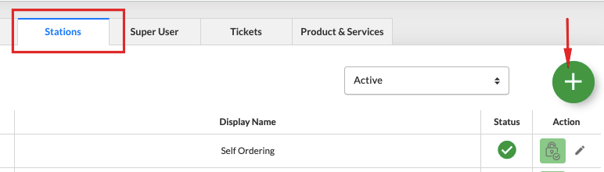

1. Login to the partner portal and navigate to your account.
2. Go to the Stations and click + as shown in the image above.

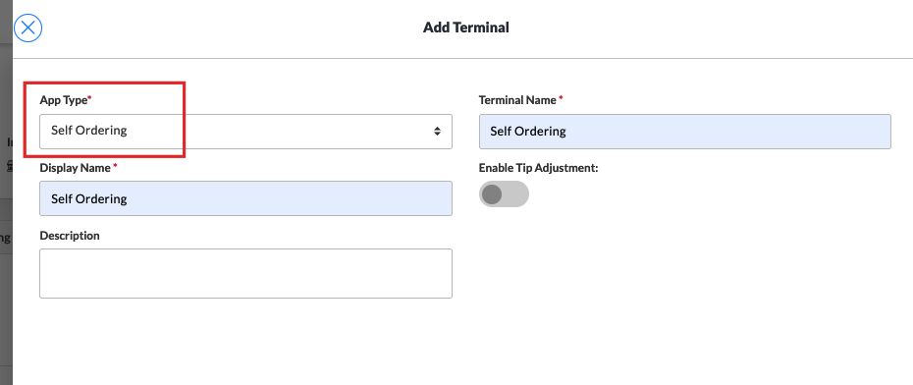

1. Make sure to select **Self Ordering** in the App Type.
2. Put the terminal name and display name.
3. Click **Save**.

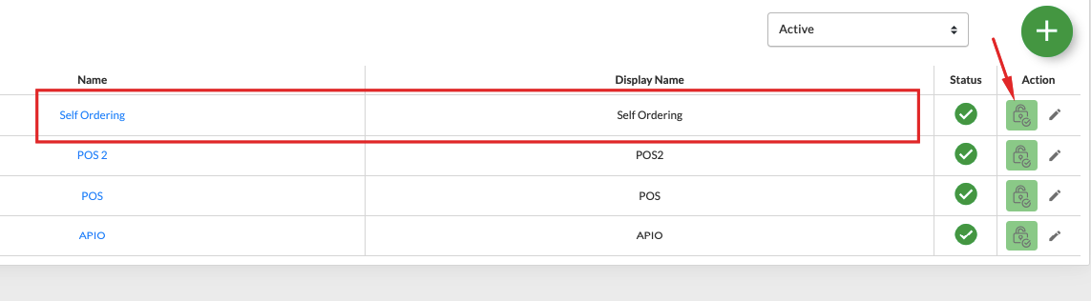

1. The Self Ordering station will be added as shown in the image above.
2. Select the lock icon to set up the payment gateway.

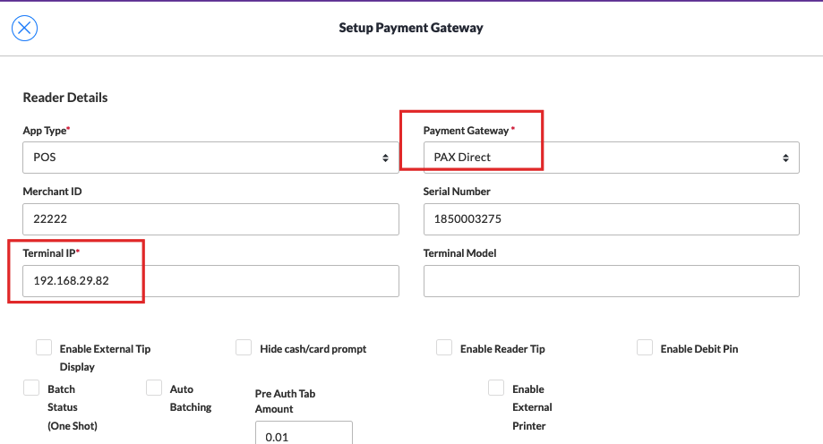

1. Select **PAX Direct** in the payment gateway.
2. Enter the **Terminal IP** (you can get it from the PAX device).
3. Click **Save**.

## Setup the Self Ordering Terminal

This step requires you to create a terminal from the backend portal and assign a self-ordering terminal type to it. Here are the steps.

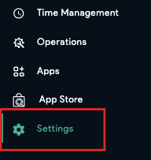

1. Login to the backend portal.
2. Click the **Left Navigation** button.
3. Click the **Configuration** button on the left panel.

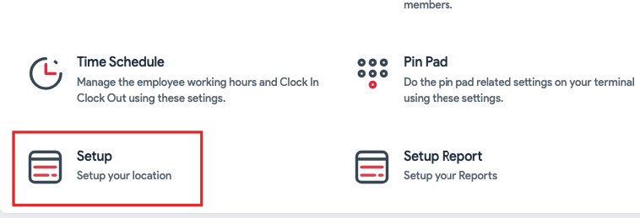

1. Tap on the **Setup.**

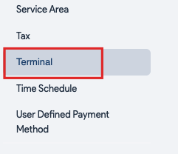

1. Click **Terminal.**

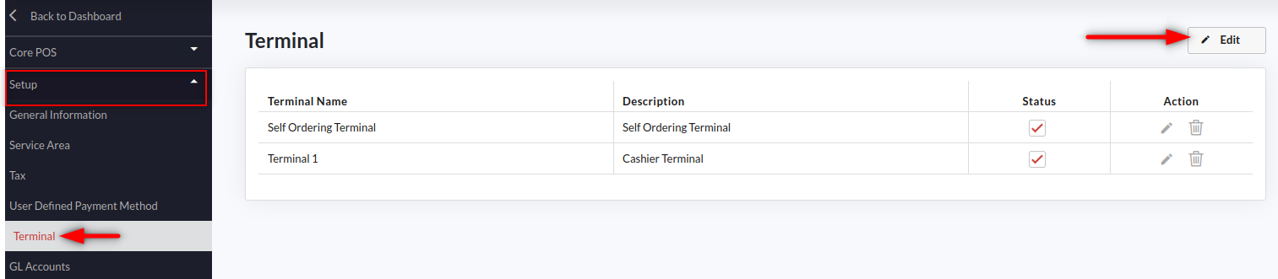

1. Click the **Edit** button on the top right.
2. Tap theicon next to the self-ordering terminal. If you can’t find the self-ordering terminal, please contact support to get it added. Or you may go to the partner portal, search your account, and add **Self Ordering** in the **Stations** tab.

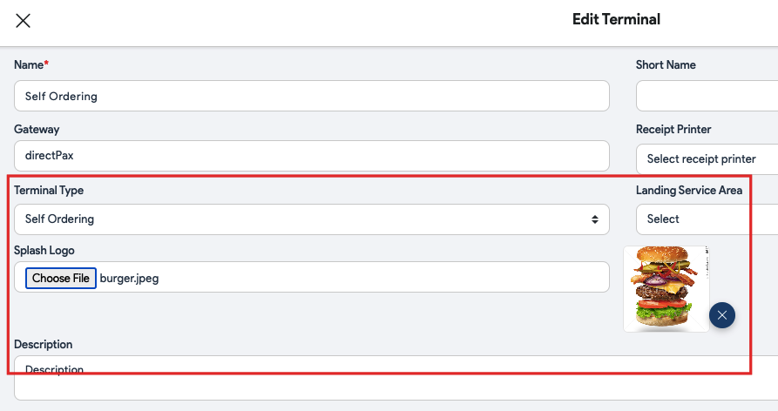

1. Fill in the information.
2. Make sure the **Self Ordering** is selected in **Terminal Type**.
3. You can also add the logo in the **Splash Logo** section.
4. Click the **Save** button at the bottom right corner.

### Assigning Service Area to Self Ordering

Once you have created a self ordering terminal, the next thing to do is assign the service areas. So you can have the main dining and quick serve service areas assigned to the self ordering kiosk. It will help the guests choose the service area based on where they want the order to get served such as at some table in the restaurant or take out. Follow the below steps to assign self ordering to the service areas.



1. Log in to the backend portal.
2. Click the **Left Navigation** button.
3. Click the **Settings** button on the left panel.



1. Tap on the **Setup.**

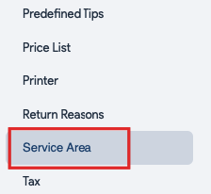

1. Click **Service Area.**

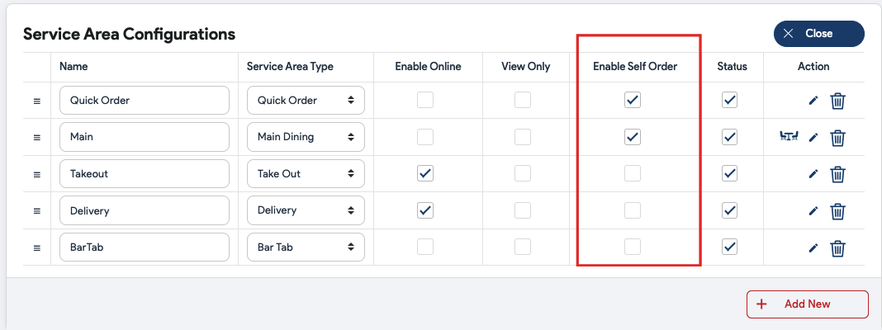

1. Click **Edit**.
2. Select the service areas that you want to enable for self-ordering. Tap the checkboxes underneath the **Enable Self Order** next to the service area(s).

## Assigning Category/Items to the Self Ordering Kiosk

Items or the whole category can be assigned to the self ordering terminal. The items (with images) will be displayed with modifiers on the self ordering kiosk. Guests can add items to the cart and pay for the order by themselves hassle-free. Here is what you need to do to assign an item or a category to self ordering kiosk.

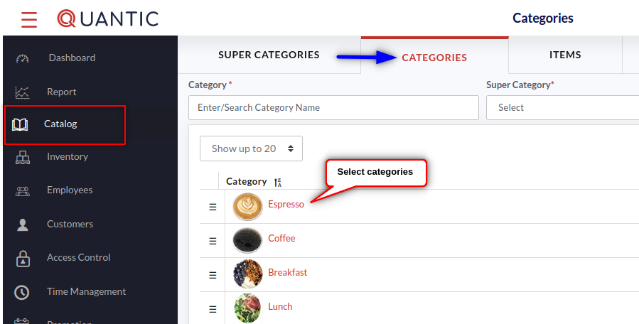

1. On the backend terminal, click the **Left Navigation** button.
2. Tap the **Catalog** icon on the left.
3. Click the **Categories** tab on top of the screen.
4. Now click the category on the list that you want to add to the self-ordering kiosk.

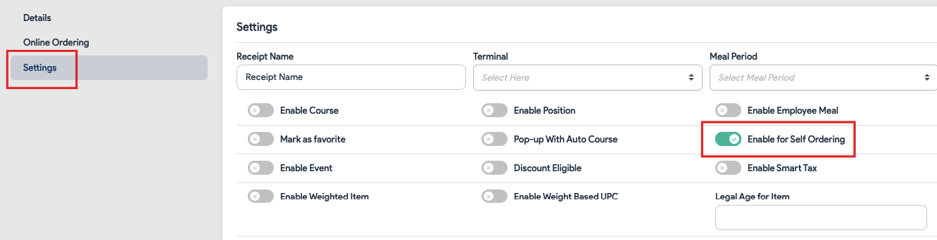

1. Click the **Settings** tab.
2. Mark the **Enable for Self Ordering** checkbox.
3. Finally, click the **Save** button at the bottom right.

| **Note**: If you do not want a specific item to show up on the self-ordering screen, you should follow the same steps as given above except visit Items instead of Categories, select an item from the list, and uncheck **Enable for Self Ordering** under the **Settings**. |
| --- |

|  |  |
| --- | --- |
| **Categories on Self Ordering Kiosk** | **Item on Self Ordering Kiosk** |

1. This is how the categories and items will show up on the self-ordering kiosk.

## Order Workflow on Self-Ordering

### Pin Pad Screen

|  | The Pin pad screen allows the employees to enter a unique employee pin meant for self-ordering only. This way you can prevent the self-ordering kiosk from any unauthorized access. So when the day starts, an employee can enter that pin and allow the guests to start ordering. |
| --- | --- |

### Home Screen

|  | This is the Welcome screen, guests can tap anywhere on the screen to start ordering. On the top left are location name and logo. Merchants can change the logo or location name from the backend portal. |
| --- | --- |

|  | A new screen will slide up. Here your guests can choose the apt option based on whether they have their number registered with the restaurant. |
| --- | --- |

|  | * **Mobile Number**: Those who have registered their number, click the **Mobile Number** tab and enter the registered number in the field. |
| --- | --- |

|  | * **Guest**: If a guest is not registered, they can access the self-ordering terminal as a guest by clicking the **Guest** button. |
| --- | --- |

|  | * **Join**: Guests can get themself registered by clicking the **Join** button. Moving forward the details need to be entered, such as name, email, and phone number. |
| --- | --- |

|  | Next, the guest should select the service area where he/she wants to get served. Once done, the guest will be forwarded to the order screen where the items can be selected and added to the cart. |
| --- | --- |

### Placing an order

|  | 1. This is the first screen that appears after selecting the service area. It displays all the parent categories the store has. 2. These categories consist of all the items that a store sells from the self ordering kiosk. Guests can tap on the category to explore the menu items. |
| --- | --- |

|  | 1. Here is an example of the Specialty Lattes category. The Search button on the top makes it easy for guests to look for any item on the kiosk. 2. Customers can select an item by simply tapping on it. A new screen will appear where the guests can select the modifier, select the size and customize their order as per their choice. |
| --- | --- |

|  | 1. Here the customer has chosen **Peppermint Mocha** latte from the items list. 2. Now the modifier needs to be selected in order to customize the drink. It helps the chef to have precise information about the order. 3. The modifier group (Size, Hot/Iced, Espresso Choices) and modifiers (Whole Milk, Nonfat Milk) can be added and associated with an item from the backend portal. |
| --- | --- |

Below is the detailed information about the modifier groups and modifiers.

- The numeric value encircled with red indicates the forced modifier group. At least 1 modifier needs to be selected from this group. The minimum modifier count will be mentioned next to the modifier group.

- The numeric value in green on the top indicates that the minimum number of modifiers have been selected from this group.

 - Other modifier groups without any number indication are optional modifiers.

|  | 1. Once you have selected the modifiers, click the  button at the bottom left corner.      1. The button will display the item price inclusive of the modifier price and tax. 2. To add more items, click the  button on the top left corner, select the item and repeat the same steps as given above. |
| --- | --- |

|  | 1. The cart screen will slide up displaying items (in green), modifiers (in grey), and price breakdown mentioned next to the item and modifier. 2. You can still edit or remove items from the cart screen by clicking the  or button. 3. The item count can be managed using the  button. 4. Order subtotal, tax, and balance due can be seen at the bottom of the Cart screen. 5. Once all the items are added to the cart, click the  button on the cart screen and move forward to the checkout page. |
| --- | --- |

|  | 1. Click the  button at the bottom to move forward to the payment screen. |
| --- | --- |

### Accepting the payment

|  | * **Cash**- If cash is chosen to pay for the order, a receipt will be generated with the order number printed on it. Guests can take that receipt to the server and wait for the order to be prepared and served. * **Credit Card**- Orders can be paid via credit cards by swiping the card on the payment terminal. * **Gift Card**- To pay via gift card, tap on the Gift Card button on the payment screen and swipe the gift card on the payment terminal. Guests can also enter the gift card number manually on the payment screen. |
| --- | --- |

|  | 1. Orders paid via cash will have this receipt generated from the self ordering kiosk. Guests can take this receipt to the cashier and pay the cash on the counter. |
| --- | --- |
| **Tickets generated for cash payments** |  |

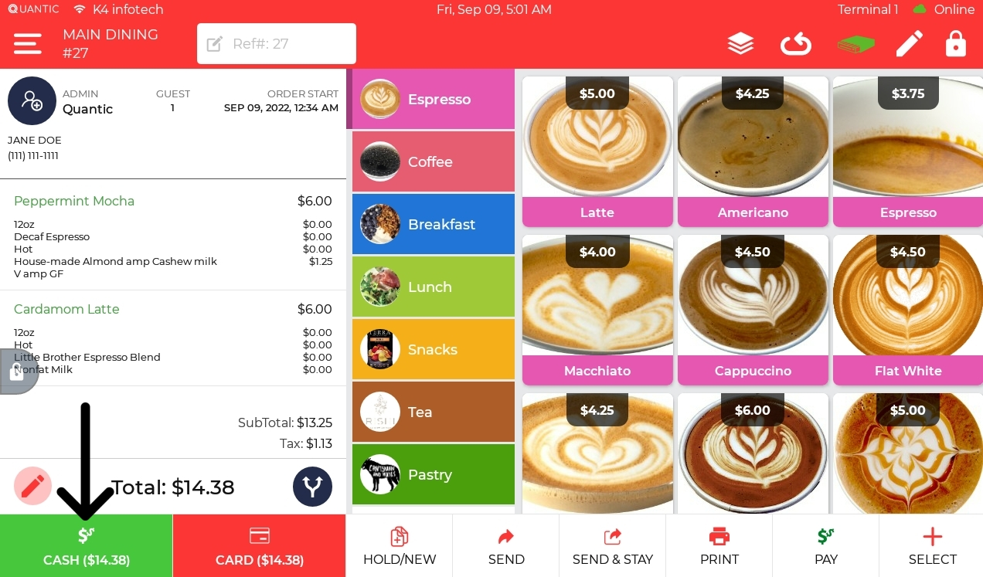

1. Servers can review the order on the POS using the order number on the receipt.
2. Once verified, click the **Cash** button at the bottom as shown in the image above.
3. Now take the cash, the order will be closed and sent to the kitchen.

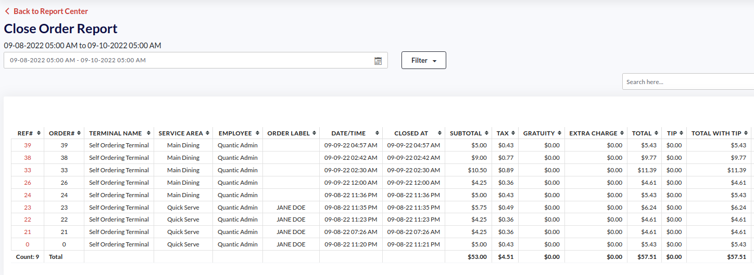

1. Merchants can track the reports for orders placed on the self-ordering terminal via Closed Order reports. The reports can be accessed on the backend portal under the Reports section.

## How to Put Order Notes on Self Ordering Screen?

Customers can put the special request in the form of order notes on the self-ordering screen for the servers or kitchen staff to act upon. This helps the guests in specifying the special requests and order modifications without any extra steps. Quantic self-ordering allows adding as many instructions for order as necessary. Order Note could be anything like *making a dish hot and spicy*, *making it less salty*, *allergic to nuts,* etc. Below are the steps to add an Order Note to the order.

|  | 1. Add items to the cart. 2. Click the **Checkout** button on the cart screen and move forward to the checkout page. |
| --- | --- |

|  | 1. Click “**Do you want to add any instructions?**” at the bottom of the checkout page. |
| --- | --- |

|  | 1. A new field will appear, enter the special instructions and click **Add**. |
| --- | --- |

|  | 1. The **Order Note** will be displayed on the checkout page as shown in the image above. 2. Click **Confirm** at the bottom. |
| --- | --- |

|  | 1. Now select the payment option and wait for the order to get served. 2. For cash payments, an order receipt will be generated, take it to the cash counter, pay cash, and wait for the order. |
| --- | --- |

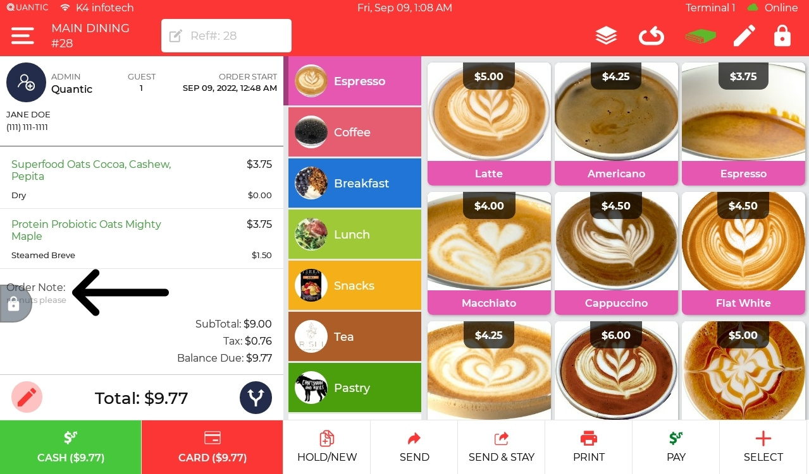

1. The order note will also appear on the POS order screen. To review it, you can visit the **Orders** section on the POS, search for the order on the list, and tap on the order number.
2. On the order screen, the Order Note will be displayed at the bottom and the same information will be forwarded to the kitchen staff via kitchen ticket.

## How to Apply Discount Coupons?

Guests can apply discount coupons to the orders on a self-ordering kiosk. The coupons can be generated from the backend portal. Once the coupon has been issued, a customer can take it to the restaurant, put the code on the kiosk’s payment screen, and can get the order at a lower price than usual. Please go through the following document to learn about how to create a coupon and redeem it from the self-ordering kiosk.



1. Log in to the backend portal and visit **Configurations** from the left navigation panel.

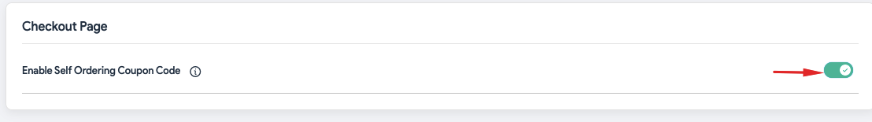

1. Search the configuration - **Enable Self Ordering Coupon Code**.
2. Tap the toggle switch next to it to enable the configuration.

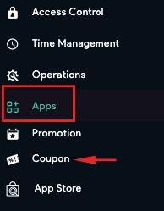

1. Go back to the Dashboard, tap on Apps, and click **Coupon**.

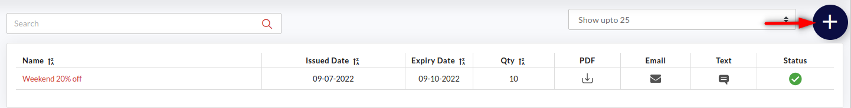

1. To add a new coupon, click the ➕ icon on the top right of the screen.

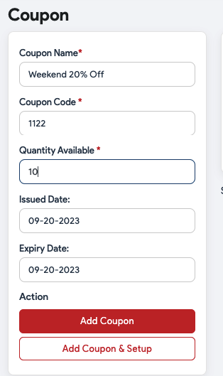

1. The **Add Coupon** screen appears where you need to follow the below steps.

* Tap on the **Coupon Name** field and enter the name of the coupon such as - Weekend 20% Off.
* **Coupon Code -** Enter the coupon code number that customers can use to redeem the coupon. For example, 1122.
* **Available Quantity -**  Here you can put the available quantity of such coupons.
* **Issue Date** and **Expiry Date -** Here you can set the eligible time period for the coupon. During this time period, the coupon code can be used and it expires beyond this time limit.
* Select Add Coupon & Setup.

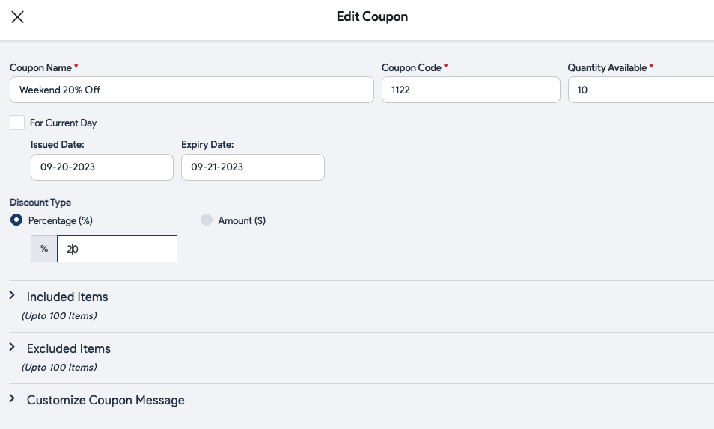

1. Enter the discount percentage in the Percentage (%) or Amount ($) field.
2. In **Included Items**, enter the item names for whom this coupon code shall be applicable.
3. In **Excluded Items**, enter the item names for whom this coupon code shall not be applicable.
4. **Customize Coupon Message -** Here you can enter the message to be displayed on the top and bottom of the coupon. Expand the Customize Coupon Message field by tapping on it, fill in the **Line 1** and **Line 2** fields with a message that you want to appear on the top and bottom of the coupon.
5. Once done, click **Save**.

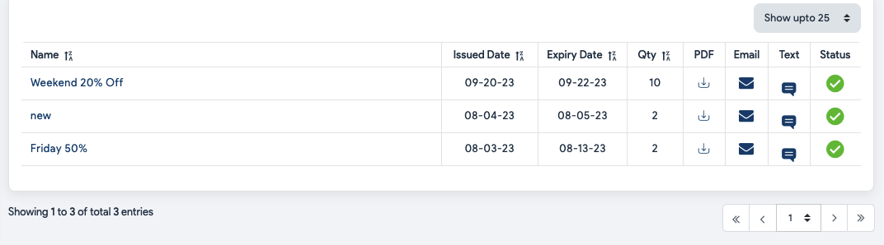

1. Once you have created the coupon, it will appear under the coupon list as shown in the above screenshot.
2. You can download the coupon, send it to the customers via text or email, and activate or deactivate the coupon as well.
   * Tap  under PDF to download the coupon.
   * Tap  to email the coupon to the customer.
   * Tap  to text the coupon to the customer.

|  | 1. This is what a standard coupon looks like. It has a coupon name written at the top and a QR code printed at the center that customers can scan to redeem. The coupon also mentions the expiration date at the bottom. Once a guest has been issued a coupon, s/he can take it to the restaurant/retail and get it scanned to avail of the discount. |
| --- | --- |

### Redeeming the Coupon

Once the guest receives the coupon, he can visit the store with that coupon and follow the below steps to redeem the coupon. Please be informed the coupon will only be redeemable at the location from where it has been created.

|  | 1. Add items to the cart. 2. Click the **Checkout** button on the cart screen and move to the checkout page. 3. Click **Confirm** on the next screen. |
| --- | --- |

|  | 1. Enter the coupon code in the **Discount Coupon** field and click **Apply**. 2. Once applied successfully, the coupon code will be displayed underneath with a green tick  adjacent to it. 3. The applied voucher discount will be adjusted and the new balance due will be displayed at the bottom. 4. Click  at the bottom to move to the payment page. |
| --- | --- |

|  | 1. Select the apt payment method from cash, card, and gift card. |
| --- | --- |

## How to Pay via Loyalty Points?

Quantic self-ordering allows the guests to earn loyalty points with every purchase and redeem those points on their purchases. Guests can also earn a sign-up bonus for registering with the store. The loyalty program including the conversion rate, accrual rate, accrual target, and sign-up bonus can be configured from the backend portal. Please follow the below steps to set up and start using the loyalty program on Quantic self-ordering.

### Subscribe to the Loyalty module

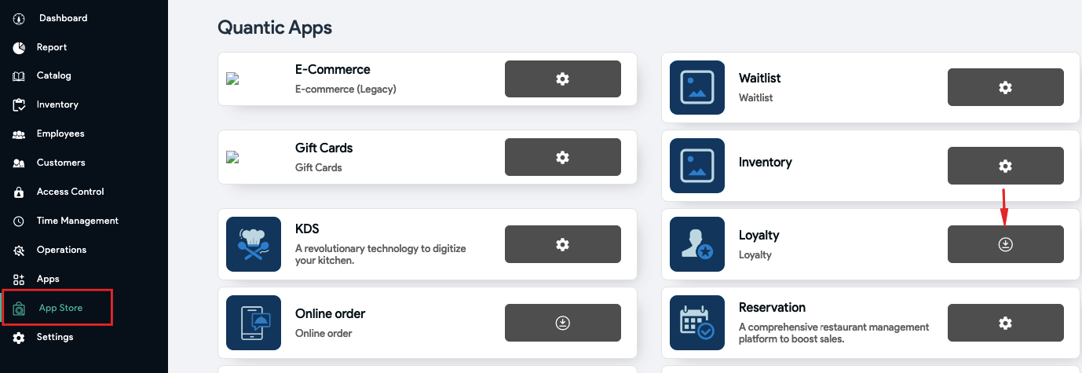

1. Sign in to the location’s back-end portal and click **App Store** on the left navigation.
2. Scroll down to locate **Loyalty** and click .

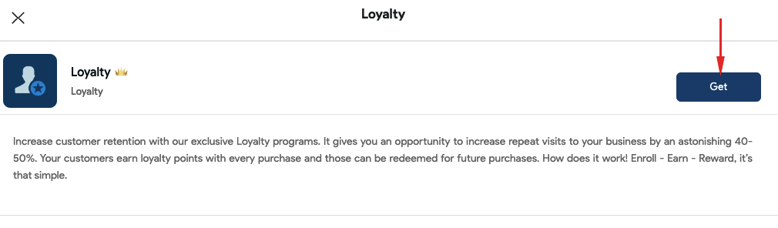

1. Click **Get** on the **Loyalty** pop-up, that same button will turn into a **Setting** button.

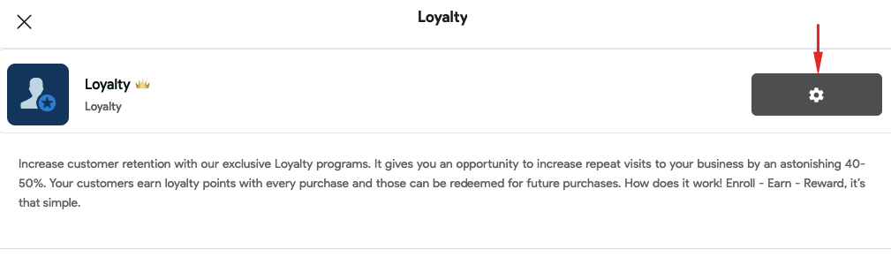

1. Click the **Gear** icon.

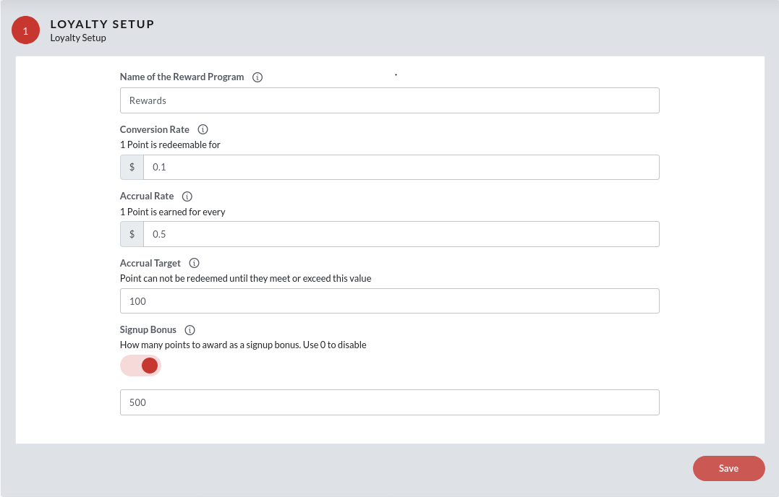

1. Great! You have just subscribed to the Loyalty module.
2. The Loyalty Setup screen will appear where you will be prompted to add other settings. Their descriptions are as follows:

* **Name of the Reward Program**
* **Conversion Rate:** How much discount will be given for each point? For eg. If we want the customer to be able to redeem 10 points for 1 dollar, the value of conversion will be $0.1
* **Accrual Rate:** How is each point earned? For eg. If we want the customer to get 2 points for every dollar spent, the accrual rate will be $0.5
* **Accrual Target:** The threshold/min. value of points before they can be redeemed by the customer.
* **Sign up Bonus:** Bonus points that a new customer will receive on enrolling with the business. Tap  button to enable the signup bonus.

1. Once done, click **Save** at the bottom.
2. The customers will now earn the points according to the set accrual rate for both Online, POS, and Self-Ordering orders.
3. Now your guests will be able to redeem and earn the loyalty points on the Self-Ordering terminal.

### Reward Points Management on Self-Ordering Kiosk

A new guest will receive a sign-up bonus on registering their phone number on the self-ordering kiosk. The sign-up bonus value is set from the backend portal as explained in the above section. Guests can check their balance points and order paid via reward points from the self-ordering terminal.

|  | 1. The guest should log in to the self-ordering terminal using their registered mobile number. 2. Click the **Mobile Number** button. |
| --- | --- |

|  | 1. Enter the registered mobile number and click **Login**. |
| --- | --- |

|  | 1. You may be asked to select the service area, choose the apt one, and click  on the top right. |
| --- | --- |

|  | 1. Click the **Reward Points** tab. 2. The Reward Points page will display the balance points, points earned, and points redeemed. 3. The previous orders and the points spent on those orders can also be reviewed in the **Recent Activity** at the bottom. |
| --- | --- |

### Redeeming Loyalty Points from Self-Ordering Kiosk

Once loyalty is set up from the backend portal, guests can redeem the points on the Self-Ordering terminal. The redeemable loyalty points will flash on the checkout page. Here are the steps on how to pay via loyalty points on the self-ordering terminal.

|  | 1. The registered guest will need to access the self-ordering by clicking on the Mobile Number button. 2. Enter the registered phone number in the field. |
| --- | --- |

|  | 1. You may be prompted to select the service area. Choose the apt one. 2. Add items to the cart. 3. Click the  button on the cart screen and move to the checkout page. |
| --- | --- |

|  | 1. Click the **Confirm** button. |
| --- | --- |

|  | 1. Review the rewards discount and click **Apply** as shown in the screenshot. |
| --- | --- |

|  | 1. The Payment Successful page will appear. Enter the email address and phone number, and click Send to get the receipt. 2. To print the receipt, click the **Print Receipt** button or click **No Thanks** to close the screen. |
| --- | --- |

## How to Add Printer in Self-Ordering Kiosk?

Quantic self-ordering kiosks can be connected to the supported thermal and impact printers. With that said, the orders placed can be printed on the receipt and sent to the kitchen for preparation. Here are the steps to help you add printers to the Quantic self-ordering kiosk. To know the supported printers and models, please scroll down to the end and see it under the “**Things you should know!**” section.

|  | 1. Go to the pin pad screen on your Android self-ordering kiosk. 2. Triple-tap the hidden icon underneath the  button. |
| --- | --- |

|  | 1. The **Printers** screen will appear, click the **Scan Printers** button on the top right. |
| --- | --- |

|  | 1. The list of available printers will display on the screen. 2. Click Add to add a printer in the self-ordering kiosk. |
| --- | --- |

|  | 1. Enter the printer details as shown in the screenshot. |
| --- | --- |

|  | 1. Once done, the printer will be added to the list. 2. indicates, the printer is offline. 3. indicates, the printer is online and ready to print. |
| --- | --- |

## How to Setup the Promotions/Happy Hours?

Restaurants can offer special promotions or discounts to guests on special events. The promotional pricing can be applied to the entire group of items in the store. Rather than changing the price of items individually, you can create a promotion rule that will apply to all the items in a category. Also, you can apply the promotion rule to the individual items and set the start and end date of the promotion rule.

### Setup the Promotion Rule

You can customize the promotion rules here, such as the start and end date/time of the promotion, the price of the item during the promotional period, and whether the promotion should keep repeating without any end date. For example, you can offer promotional prices for summer holidays, weekends, clearance sales, etc. Below are the steps to set up the promotion rule in Quantic.

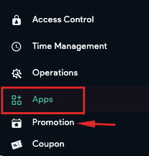

1. Navigate to the **Promotion** under **Apps** in the left navigation menu.

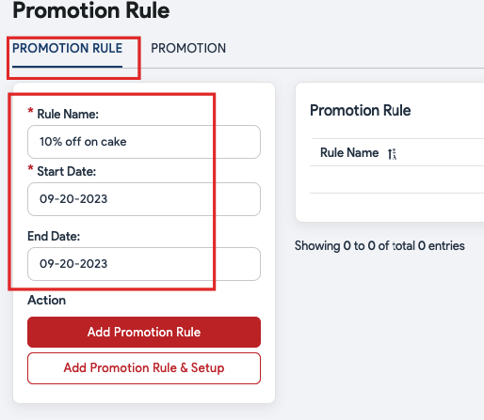

1. Select the **Promotion Rule** tab as shown in the screenshot.
2. A new window will appear here. You can create a new rule and customize it the way you want. Below are the descriptions.
   1. **Rule name**: Enter the name of the promotion rule such as 10% off on cakes, Happy Hours, Friday 20% off, etc.
   2. **Start Date**: Select the start date of this promotion rule. From this date onwards, the promotion rule can be applied to items. So if you select April/17/2022 as the start date, the promotion rule will come into effect from the 17th of April.
   3. **End Date**: Select the end date of this promotion rule. The promotion rule will end on this date. If you select April/24/2022 as the end date, this promotion will end on the 24th of April.
3. Click **Add Promotion Rule & Setup**.
4. Click  to create a new promotion rule.

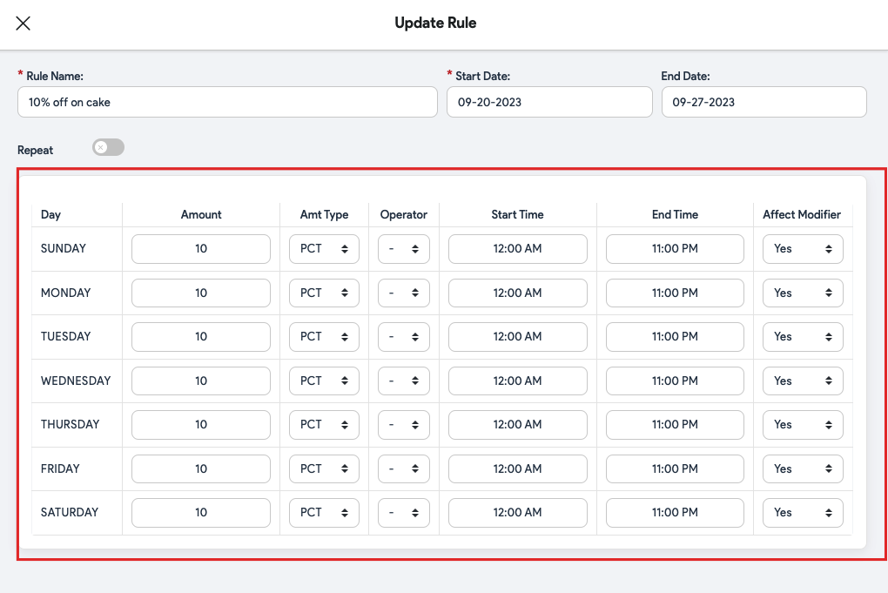

1. Enter the amount next to the day. The amount should be in numbers. So, if you want to offer the 10% off on cakes, enter 10 next to Friday, select **PCT** (percent) in **Amt Type,** and select (➖) in the **Operator Type**. Below are some important abbreviations to help set up the rules.
   1. **PCT**: Percentage%. For example, 10%.
   2. **AMT**: Amount. For example, $10.
   3. **Operator** (➖): Apply this operator when you want to offer a discount. For example, to activate the 10% off on items, simply put 10 in Amount and (➖) in Operator.
   4. **Operator** (➕): Apply this operator when you want to increase the price of items. For example, to raise the price of items by 10%, simply put 10 in Amount and (➕) in Operator.
   5. **Operator** (=): Apply this operator when you want to override the existing amount of the item. For example, if you put 10 in the Amount field and select (=) operator, the existing price of the associated item will be overridden to $10.
2. Next, you should select the start and end time to choose the duration during which you want the promotion rule to remain in effect during the day. For example, you want the 10% off on cakes promotion rule to stay active between 10:00 am to 11:00 pm, so select 10:00 am as the Start Time and 11:00 PM as the End Time.
3. Select **Yes** in the **Affect Modifier** field if you want the promotion rule to be applied to the associated modifiers as well. Let’s understand this with an example of an item - *Hot Wings*. It is usually served with a *Sweet Chilly* modifier. So, there can be two scenarios - first, you want the promotion rule to be applied to the modifier as well, and second, you want to exclude the modifier from the promotion rule. Let’s see the calculations in both scenarios.

**Scenario 1**. Applying the promotion rule on item and modifier.

You apply a 10% off promotion rule on Hot Wings and select **Yes** in the **Affect Modifier** field; the final price will be calculated on *Hot Wings + Sweet Chilly*, as given below.

Price of Hot Wings = $5

Price of Sweet Chilly = $1

Total Price = $6

Final price after applying the promotion rule (10% off) = $5.4

**Scenario 2**. Applying the promotion rule on item only.

You apply a 10% off promotion rule on *Hot Wings* and select **Yes** in the **Affect Modifier** field; the final price will be calculated as given below.

Price of Hot Wings = $5

Price of Sweet Chilly = $1

Final price after applying the promotion rule (10% off) = $5.5.

1. Don’t forget to click the **Save** button to save the changes.

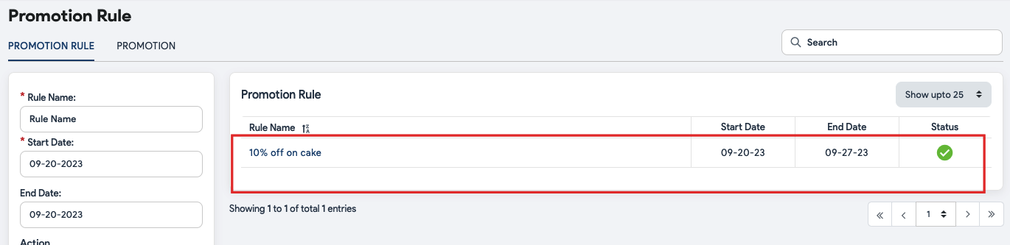

1. The added promotion rules will appear under the **Promotion Rule** tab, as shown in the screenshot above.
2. The **Start** and **End Date** will also appear next to the promotion rules.
3. The  under **Status** symbolizes the promotion rule is active and  means a promotion rule is inactive. You can tap on the  or  to reverse the action.

### Setup the promotion

Once you have set up the promotion rules, it’s time to create an event and associate a promotion rule with it. This section will allow you to choose employees who can apply the promotion rule to an item and the service areas and terminals where the promotion rule can be applied. For example, you have an Easter Event around the corner. And you want to offer 10% off on chocolate truffles. Here is how you can do it - create a promotion rule called 10% off on chocolate truffles, create a promotion called the Easter Event, and associate the chocolate truffles item with Easter Event. Follow this path to associate an item with specific promotion - **Catalog** > select **chocolate truffles cake** > **Additional Settings** > **Enable Event**.

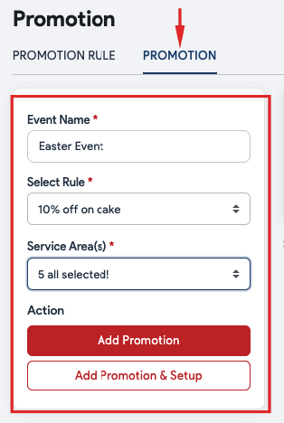

1. Tap the **Promotion** tab as shown in the screenshot above.
2. A new window will appear, here you can create an event and customize it the way you want.
   1. **Event Name**: Enter the event name. For example, Easter Event.
   2. **Select Rule**: Tap this field and select the promotion rule from the drop-down. This will associate the event with the selected promotion rule, and the preset prices will apply during the promotional period. For example, you can select 10% off on cake promotional rules for the Easter Event.
   3. **Service Areas**: Select the service areas where you want this promotion to be applicable.
   4. Click **Add Promotion & Setup**.

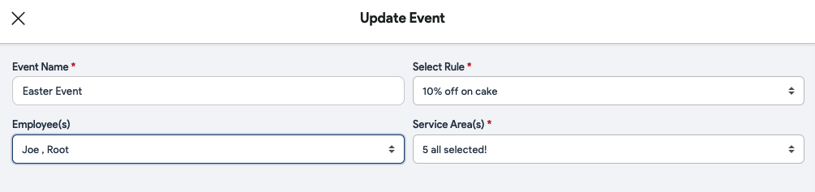

1. **Employees**: Select the employees to authorize them to apply this promotional price. Other employees won’t be able to apply the Promotion.
2. Once done, please click the **Save** button.

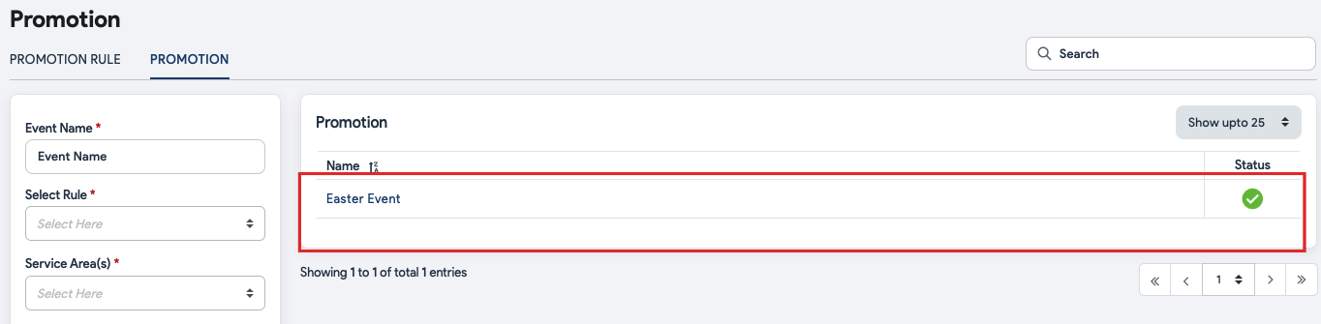

1. The added events will appear under the **Promotion** tab as shown in the screenshot above.
2. The  under **Status** symbolizes the promotion is active and  means a promotion is inactive. You can tap on the  or  to reverse the action.

### Associate an item with the promotion

Once you have created the promotion and set up the rules, the next step is to associate the items with an apt event. It allows you to offer the items as per the rules set in the promotional rule. For example, you can set the chocolate truffle to be associated with the Easter Event (10% off promotion rule).

| **Note**: You can also associate the entire category with a promotion. This will apply the promotion rule to all the items in that category. To apply the category-level promotion, go to the **Catalog** > **Category** > **select category** from the list > **Additional Settings** and tap the checkbox next to the **Enable Event.** Now select the event to be applied and click **Save**. |
| --- |

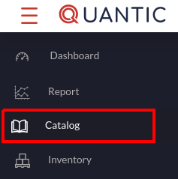

1. Navigate to the **Catalog** section on the left panel.

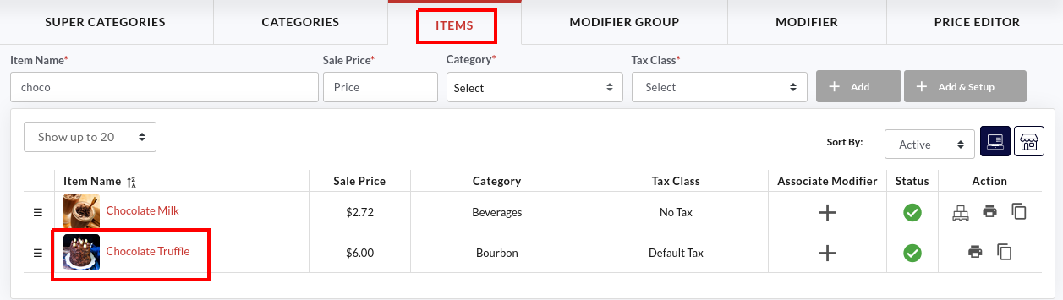

1. Click the **Items** tab and tap on the item that you want to associate with an event.

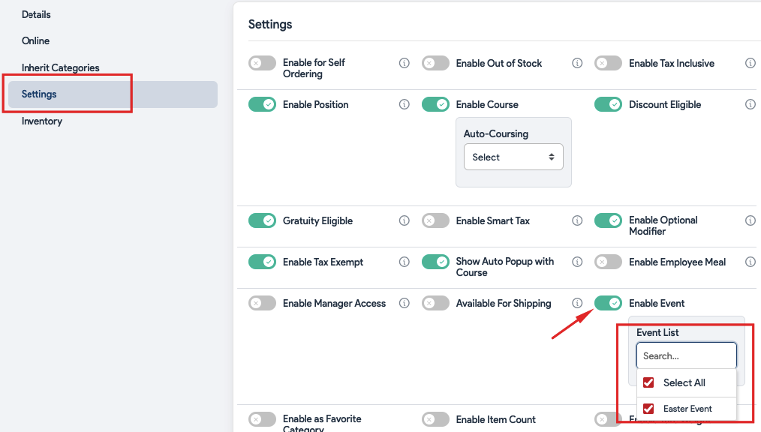

1. Go to the **Settings** tab, select the **Enable Event** option, and select the promotion from the **Event List**. The preset rules of the promotion will be applicable to this item. In this example, we have associated the *chocolate truffle cake* with an *Easter Event* promotion, and during that period, the chocolate truffle cake will be offered at a 10% lower price.
2. Once done, click **Save**.

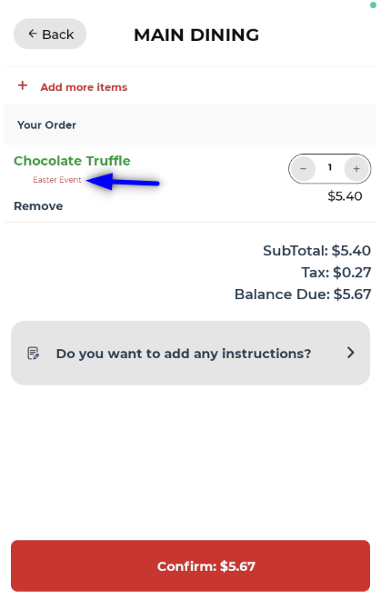

1. Take a look at this self-ordering screen, the chocolate truffle cake has been ordered during the Easter Event promotion period, that’s why the **Easter Event** is written underneath the chocolate truffle cake. The revised item price will be displayed next to the item. Here, you can see the actual price of chocolate truffle cake was $6.00, but during the Easter Event (10% off on cakes), the new price comes out to be $5.40 (exclusive of taxes).